Step1: create 2 ec2 instamce with name master and node

Fork this <https://github.com/akshu20791/apachewebsite>

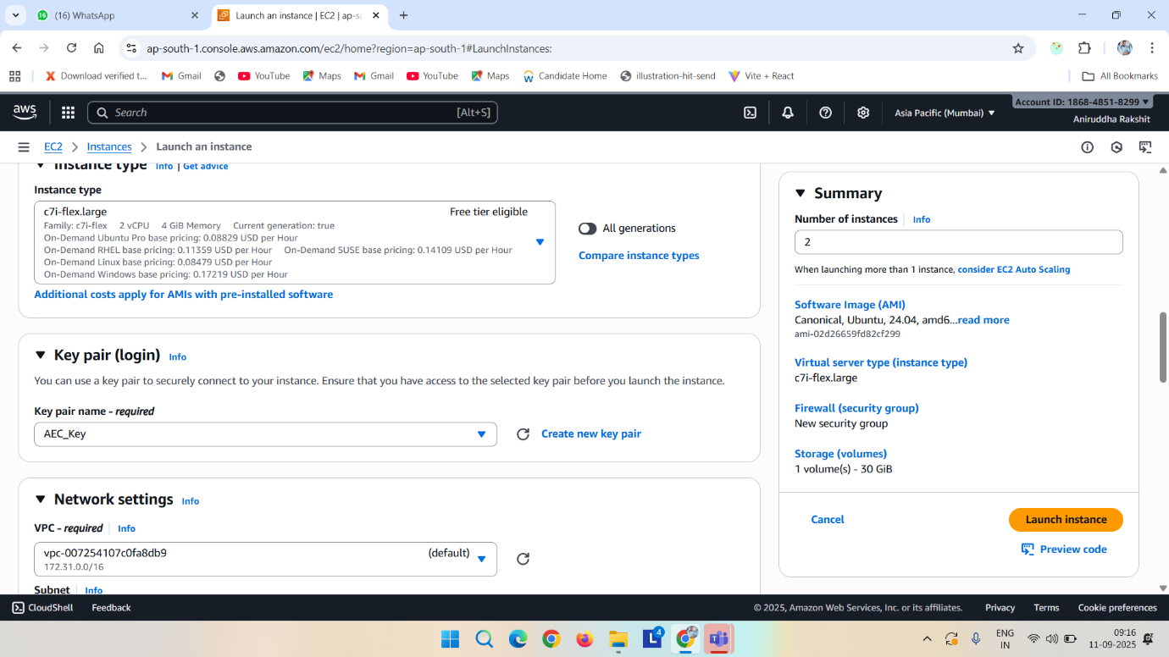



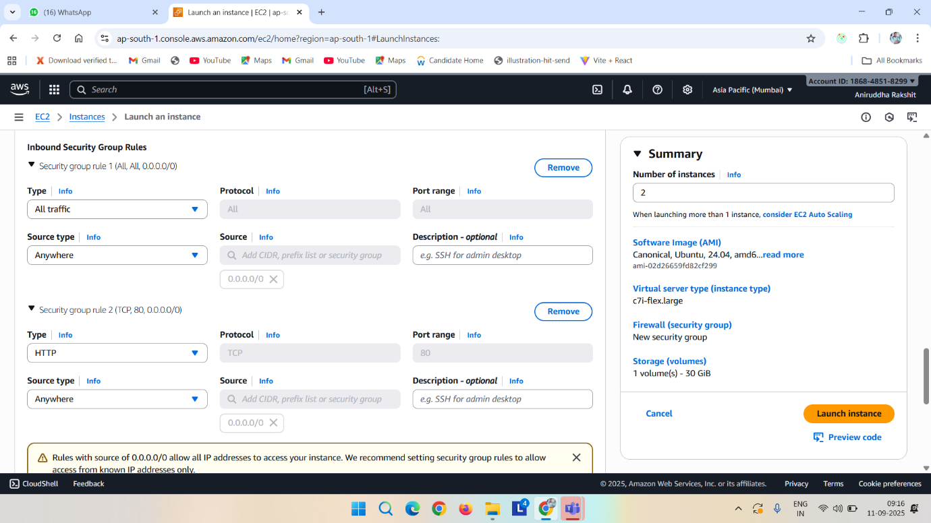

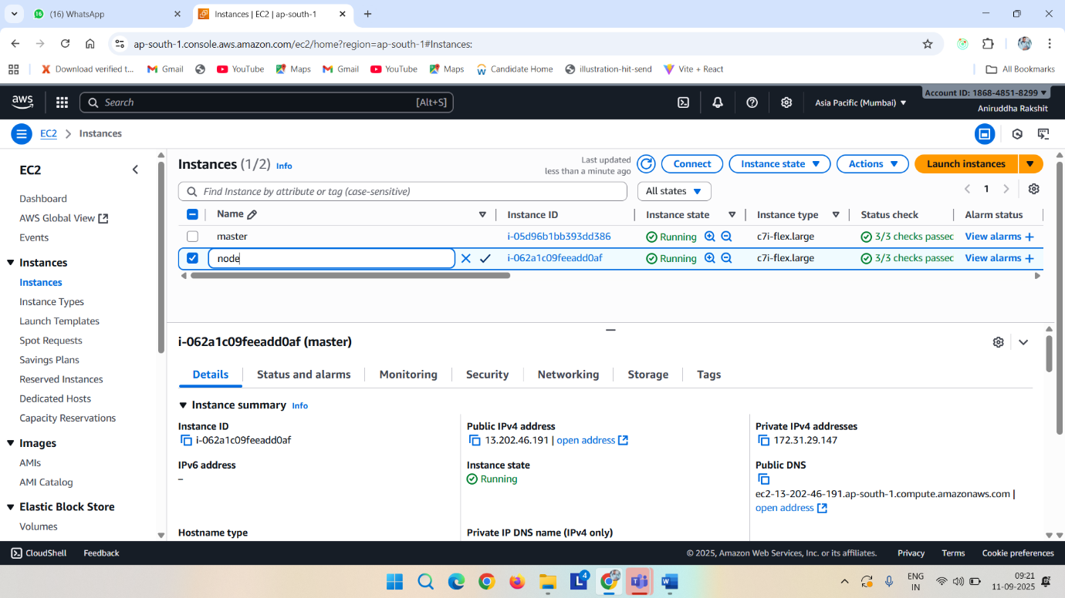

Now Connect it

And do the basic opearation in master and node

Sudo su

Apt update

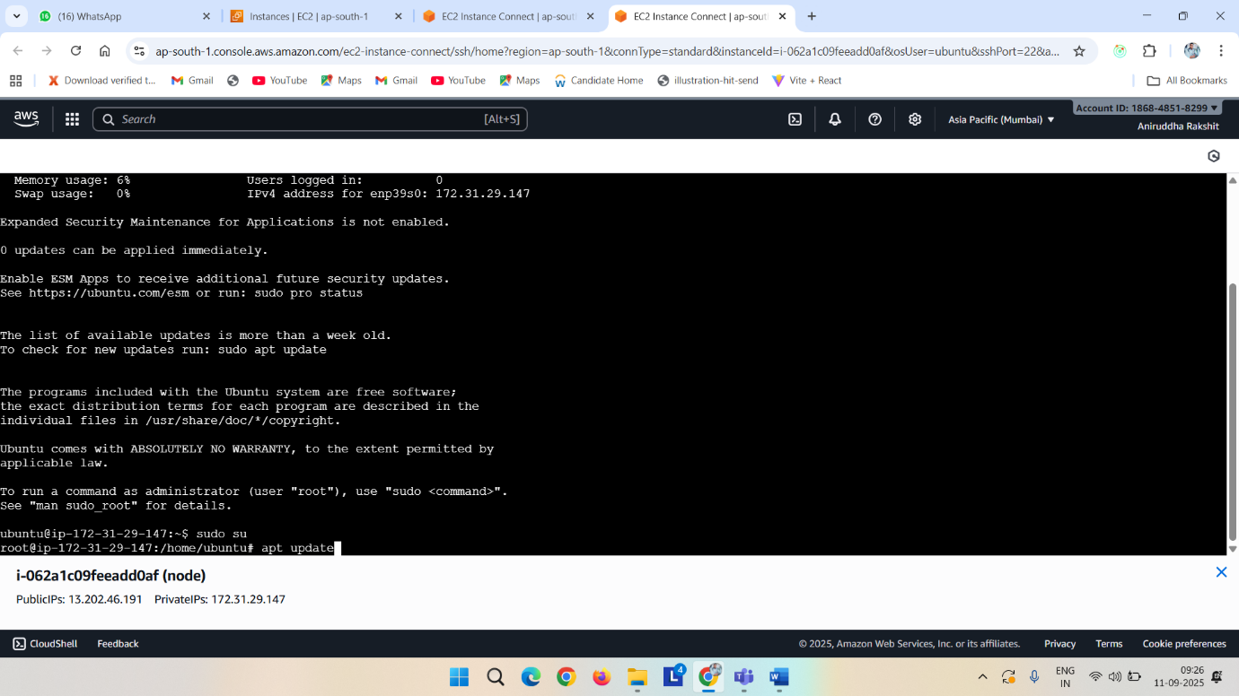

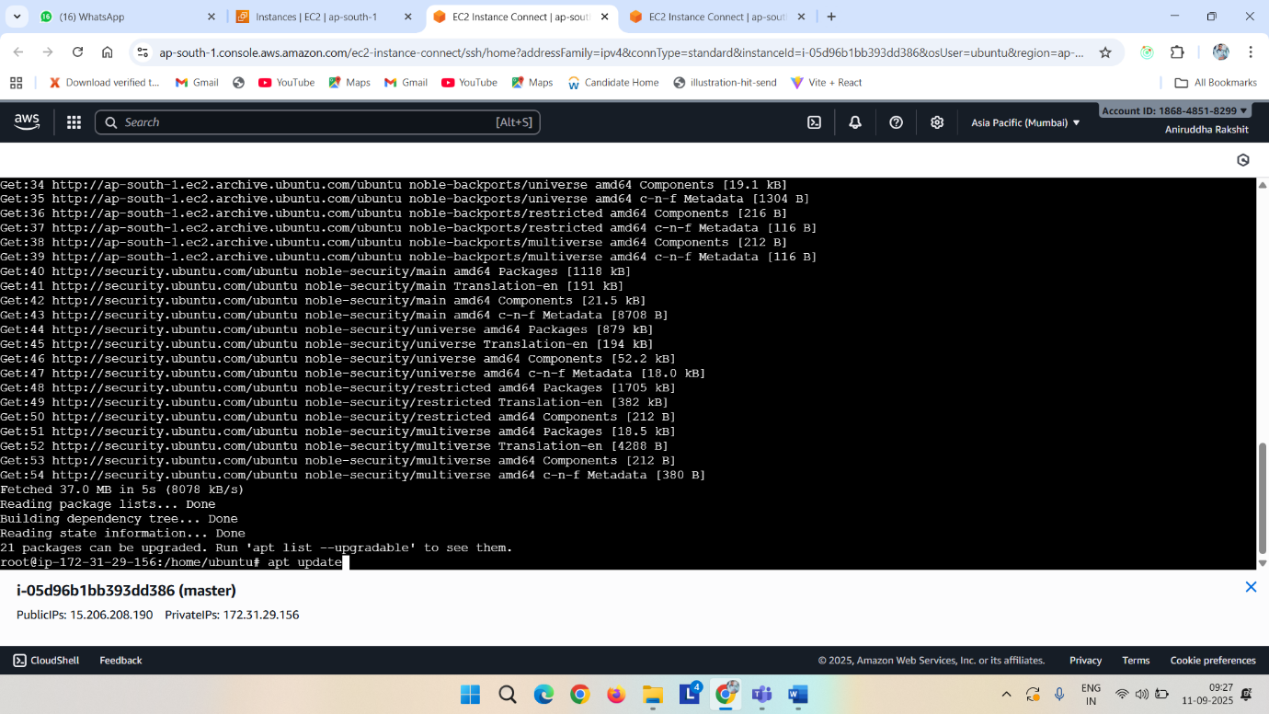

Now install

1. Docker (master machine)
2. Kubernates
3. Jenkins (master machine)
4. Ansible

apt install docker.io -y

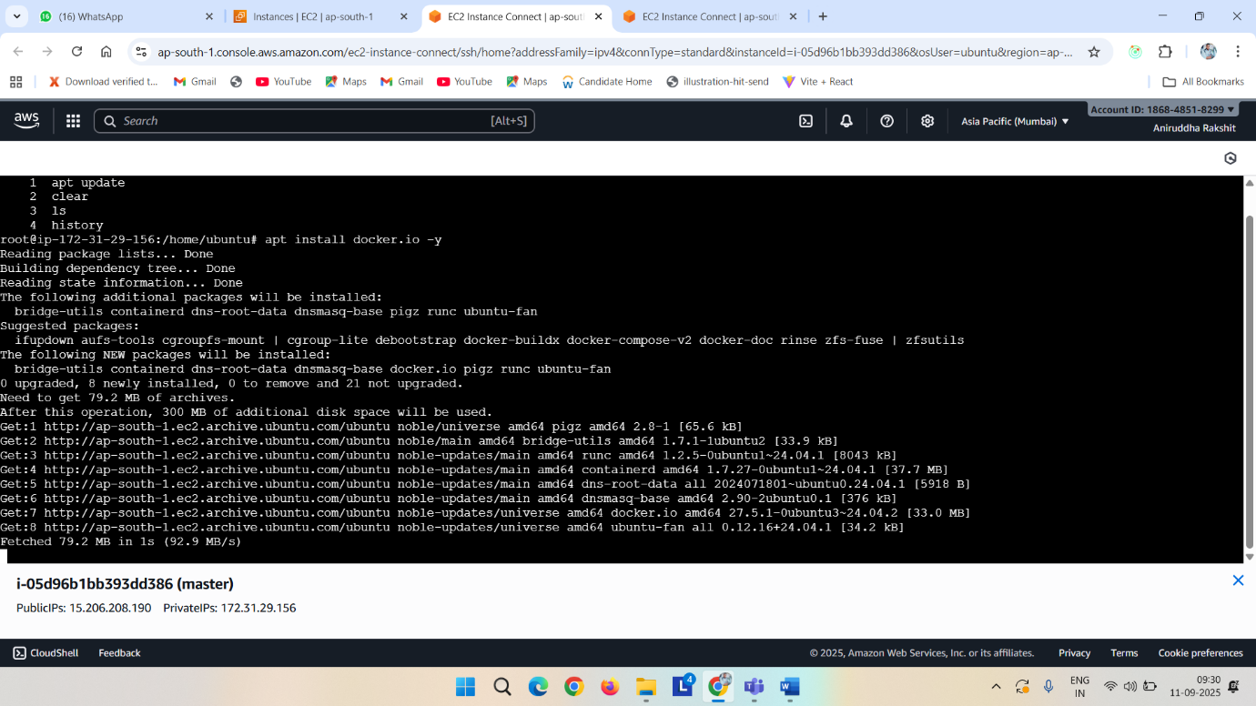

Now for jenkins

wget https://raw.githubusercontent.com/RaksAniruddha/Deployment-script/refs/heads/main/jenkins.sh

ls

chmod +x jenkins.sh

ls

./jenkins.sh

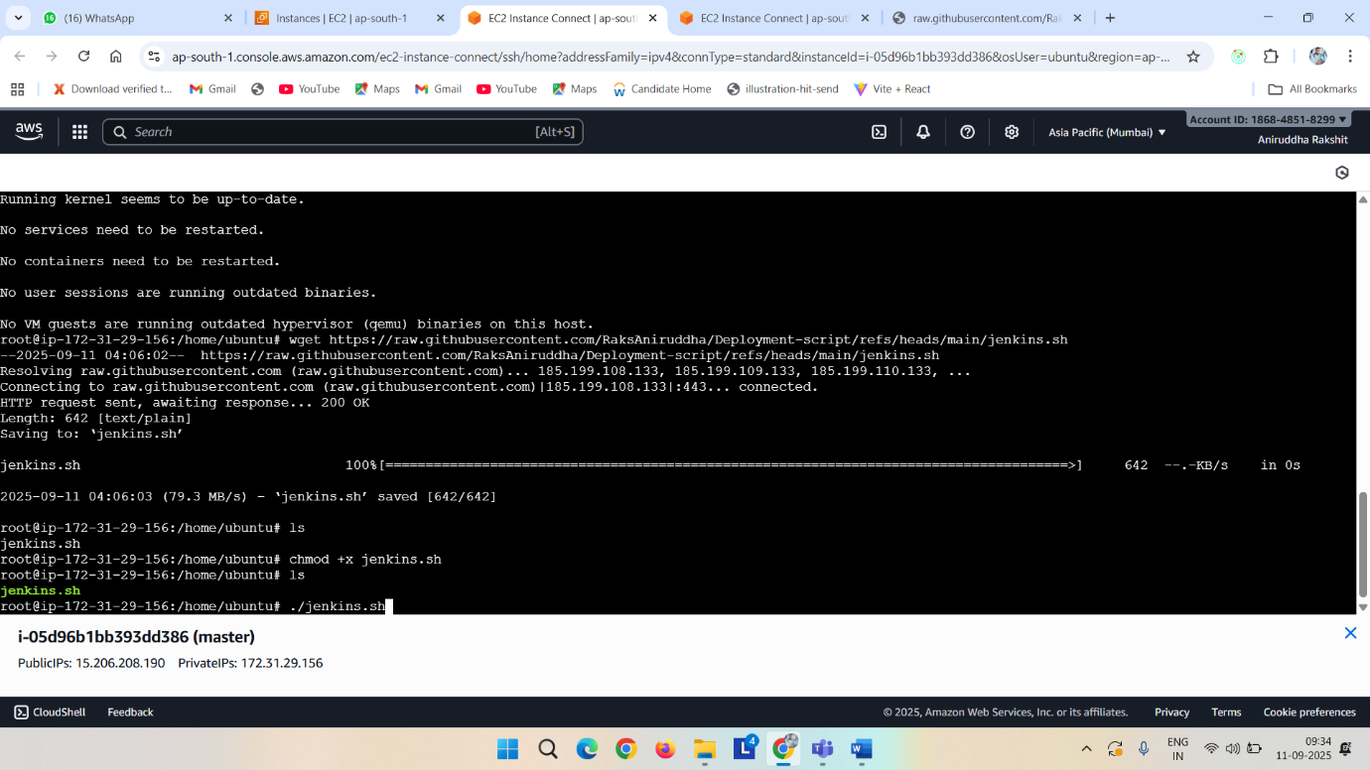

<your_master_machine_public_ip>:8080 paste it on browser

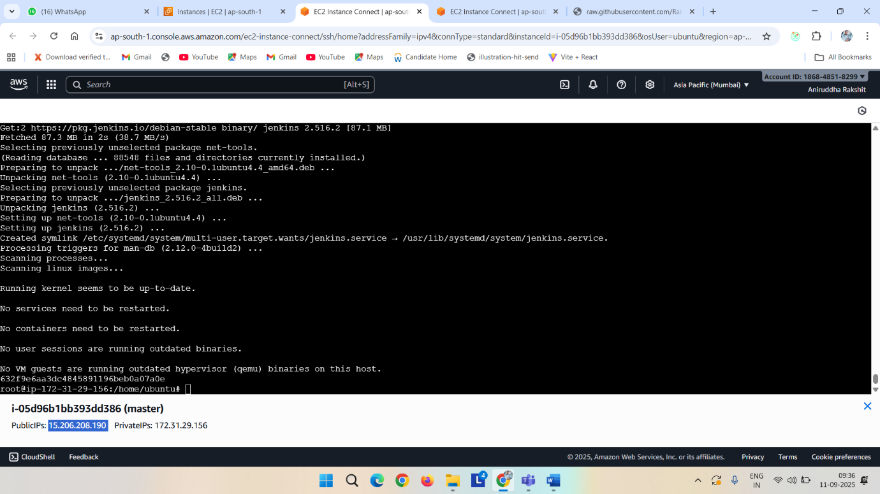

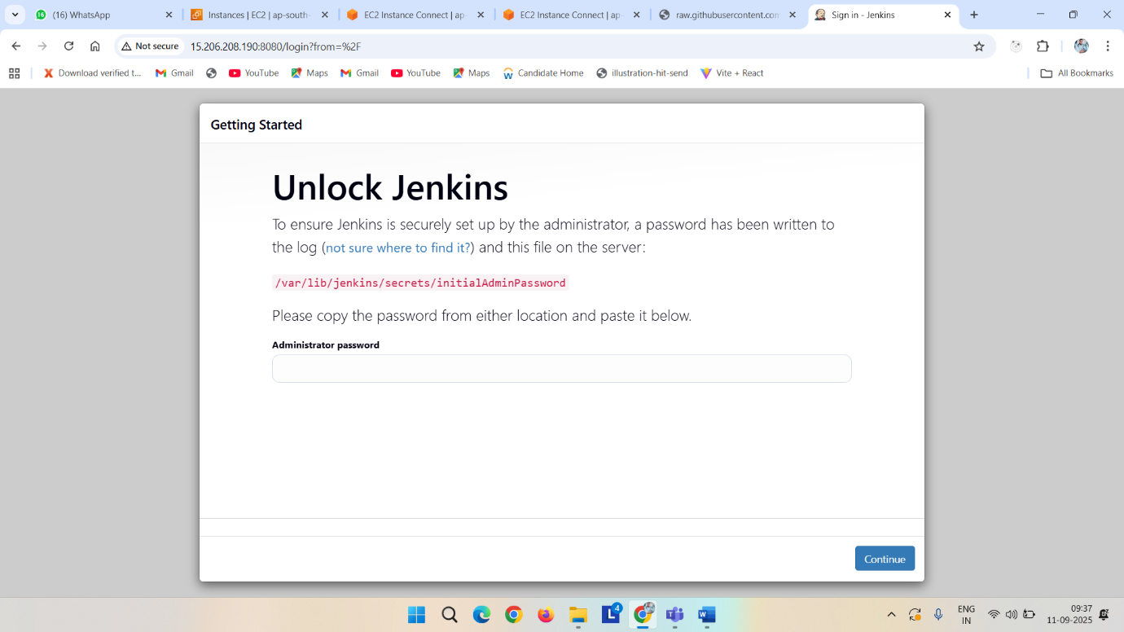

Cat /var/lib/jenkins/secrets/initialAdminPassword

Copy the password and paste it -> install suggested plugin -> set credential

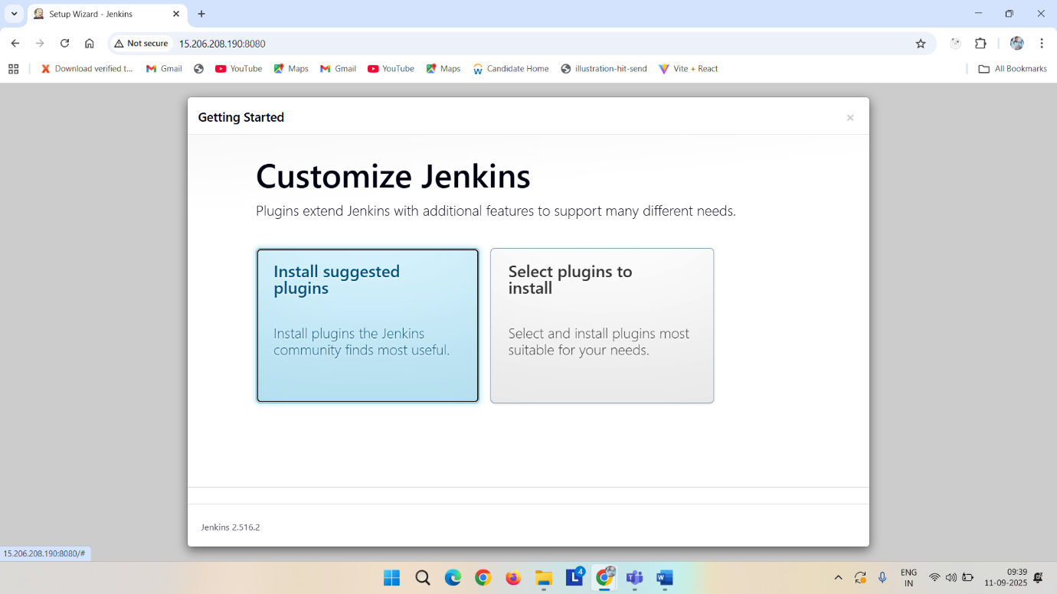

I am giving all as admin

Save and continue -> start jenkins

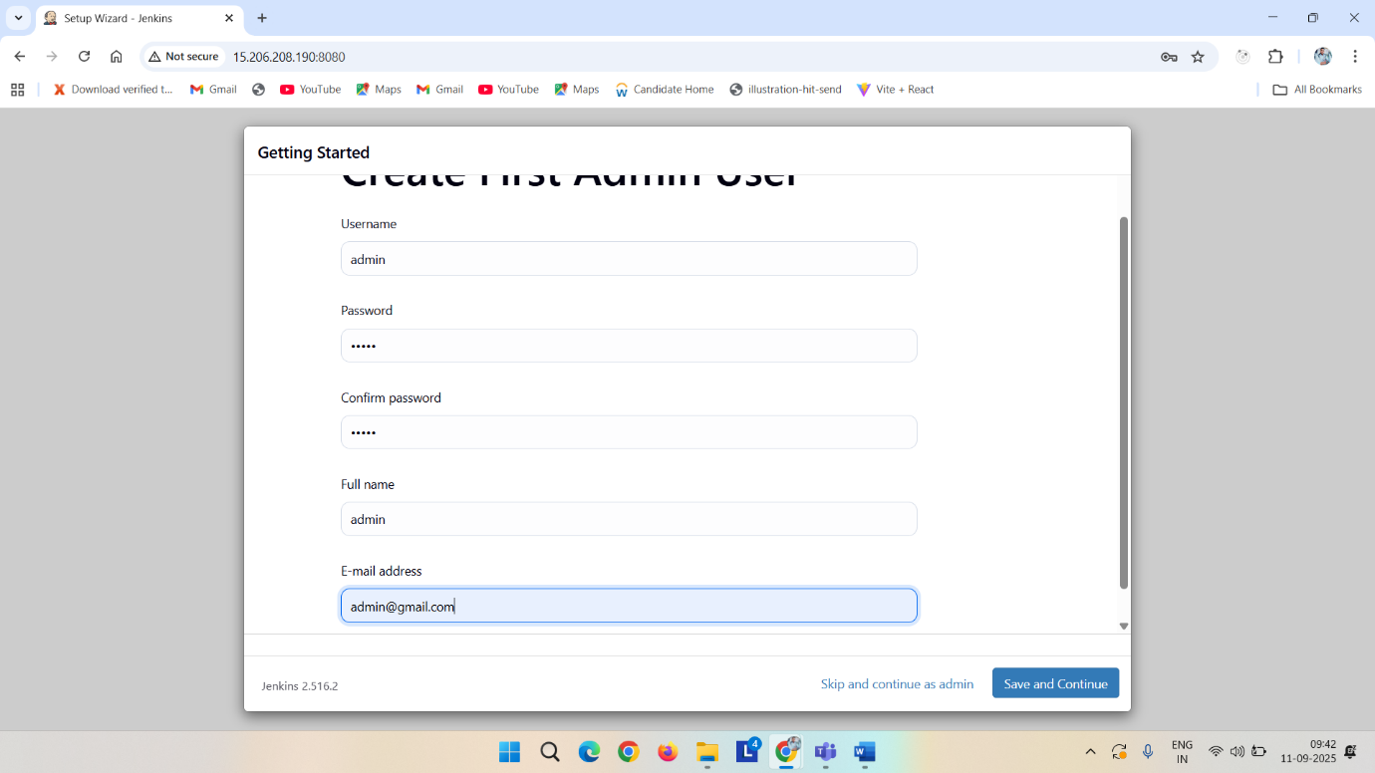

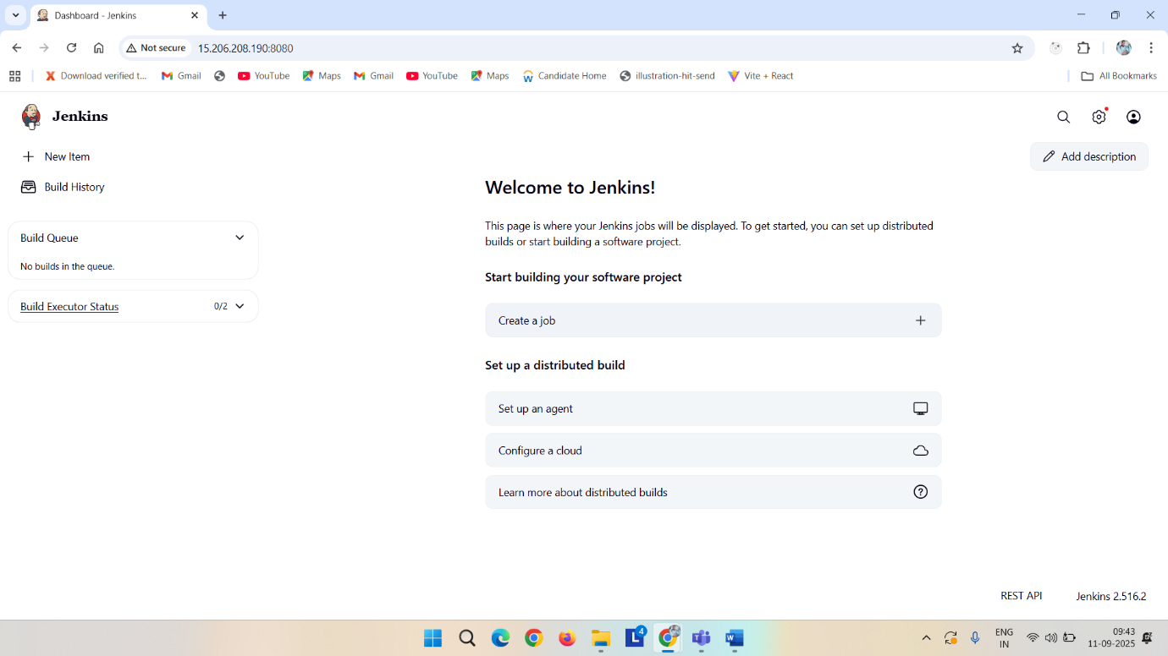

Now install kubernates

For this follow <https://github.com/RaksAniruddha/Deployment-script/blob/main/readme-k8s>

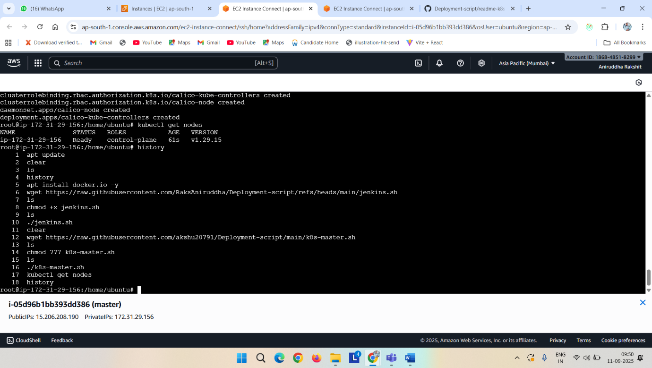

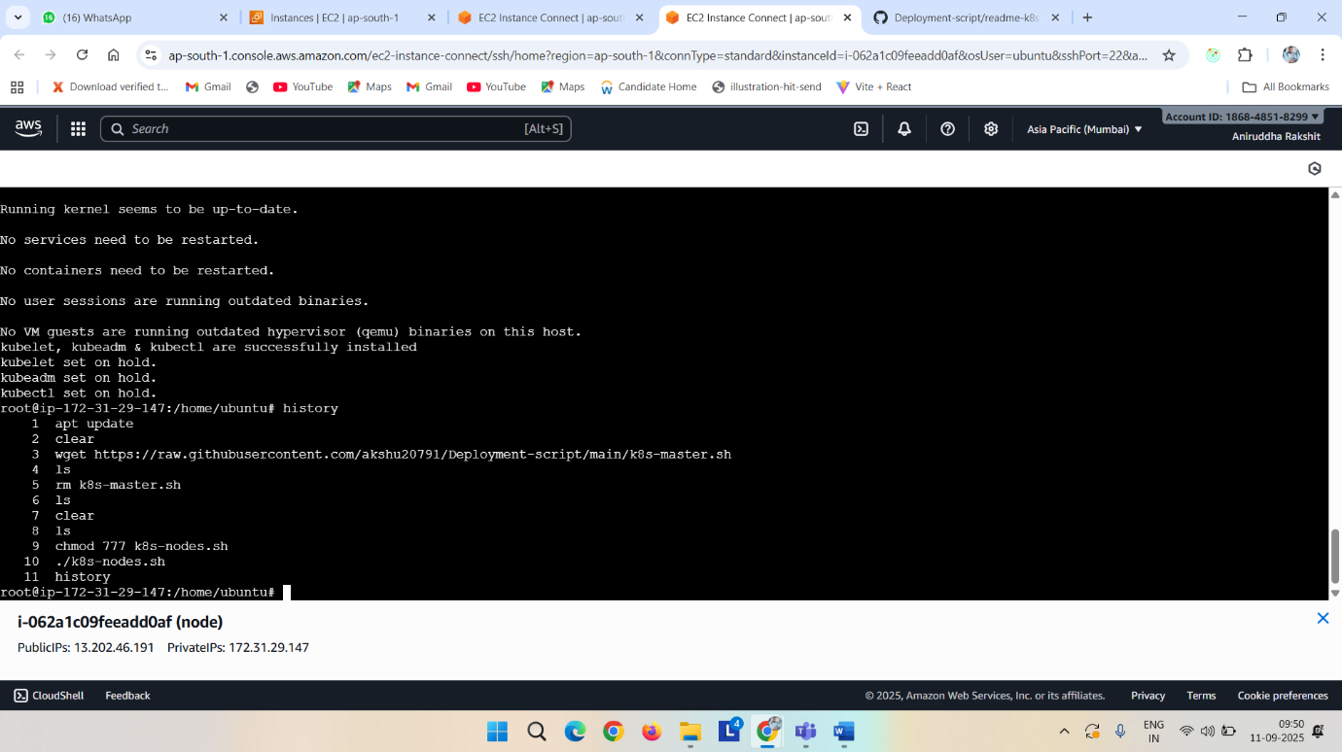

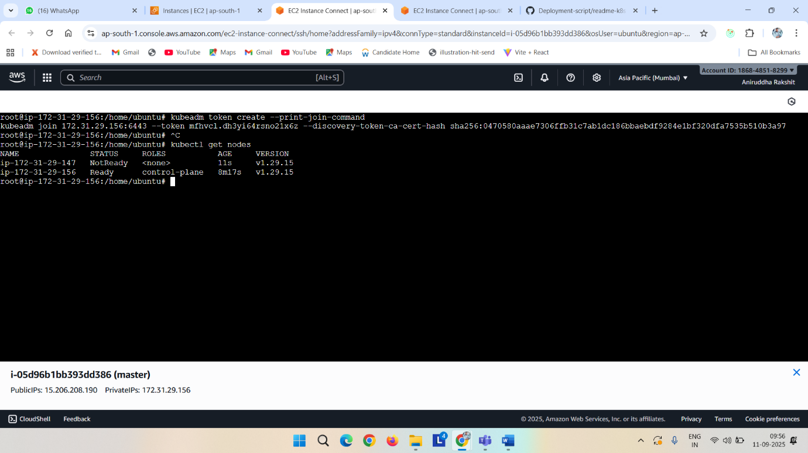

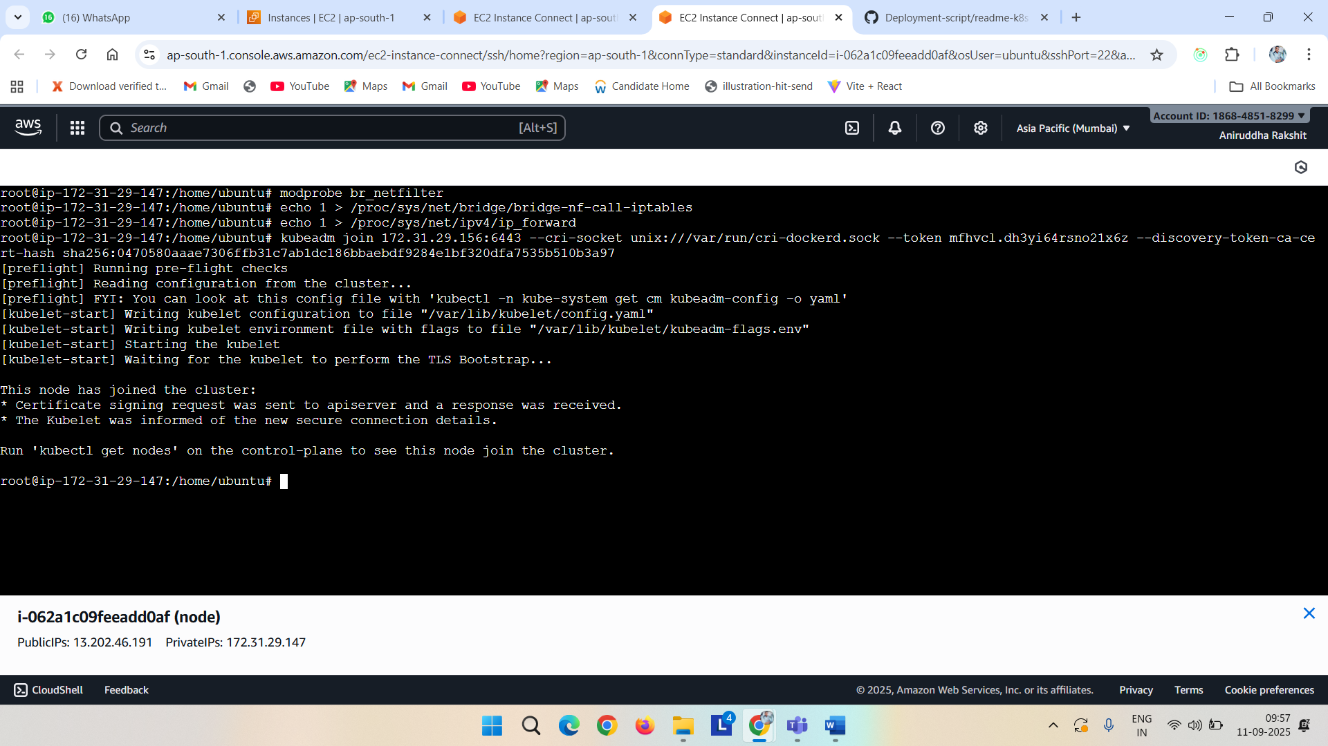

Now install ansible

Do this basic operation

apt update

apt-get install software-properties-common

apt-add-repository ppa:ansible/ansible

apt-get update

apt-get install -y ansible

vi /etc/ansible/hosts

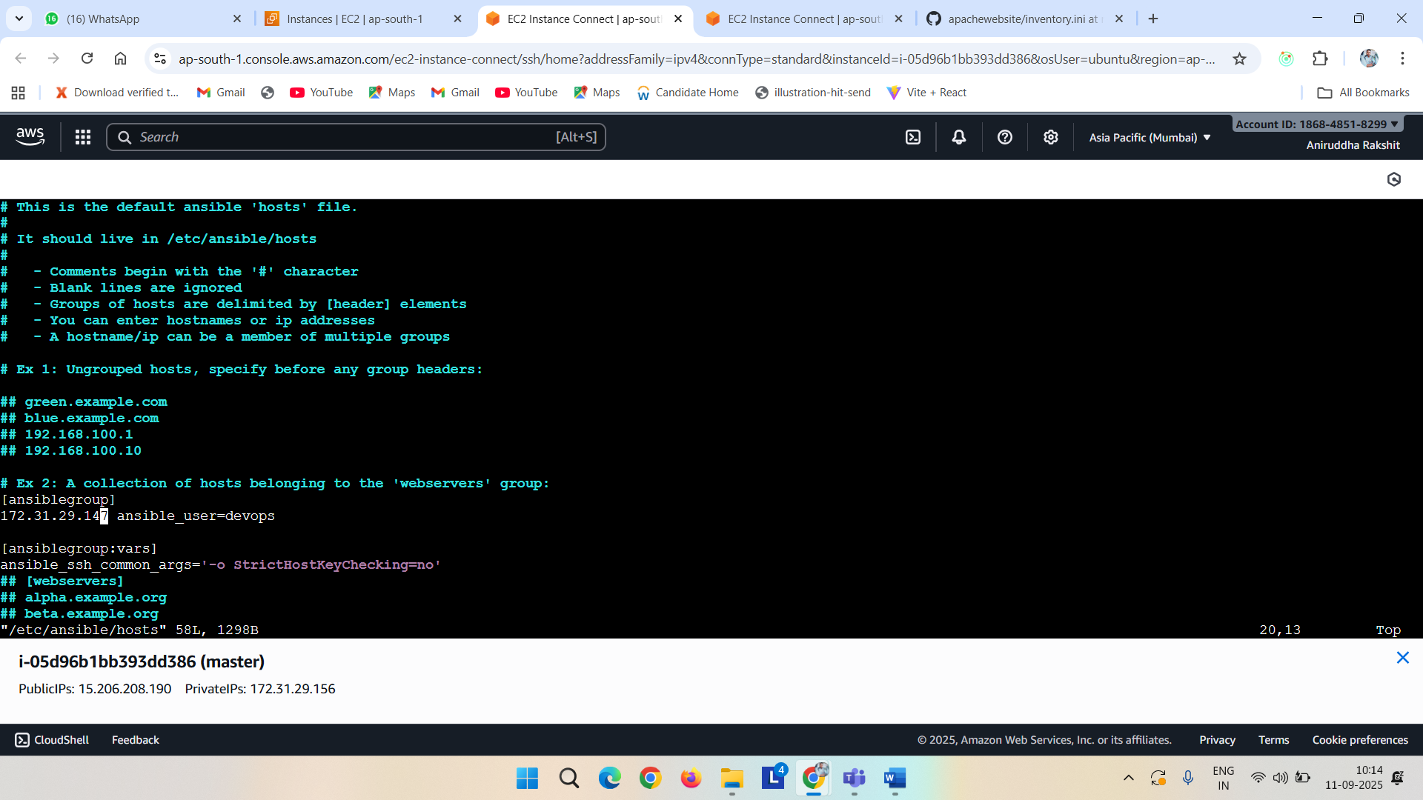

Copy the content and make a inventory.ini file on forked repository and paste it  
[ansiblegroup]

<privateipofnode> ansible_user=devops

[ansiblegroup:vars]

ansible_ssh_common_args='-o StrictHostKeyChecking=no'

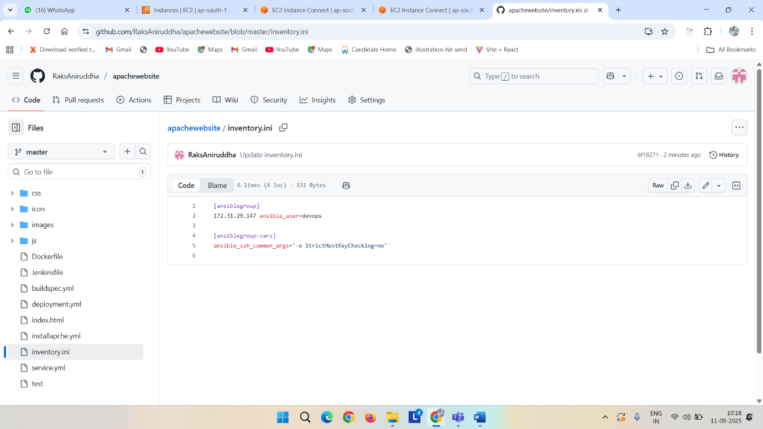

Visudo

vi /etc/ssh/sshd_config

vi /etc/ssh/sshd_config.d/60-cloudimg-settings.conf

service ssh restart

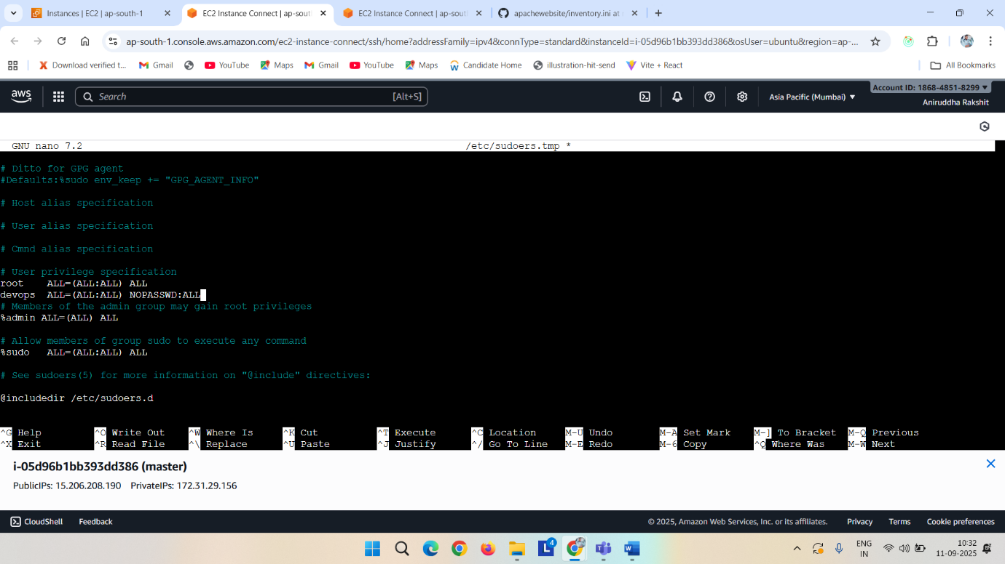

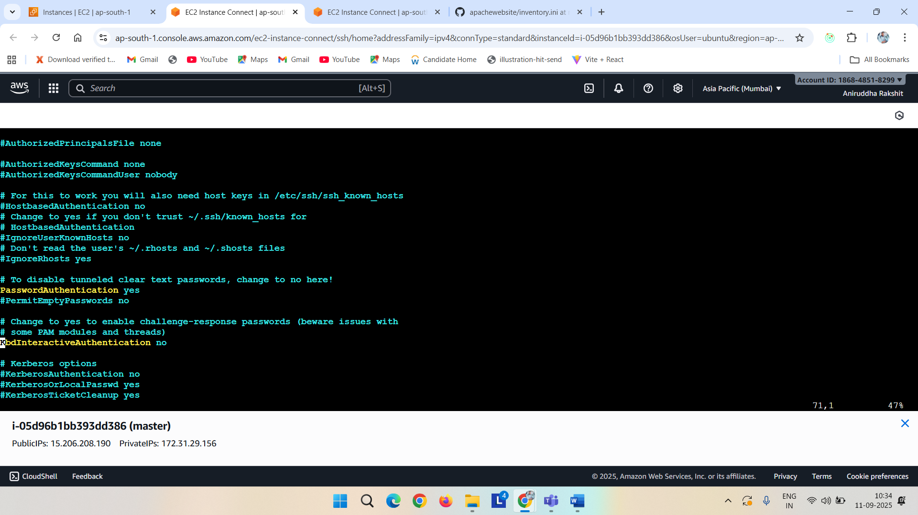

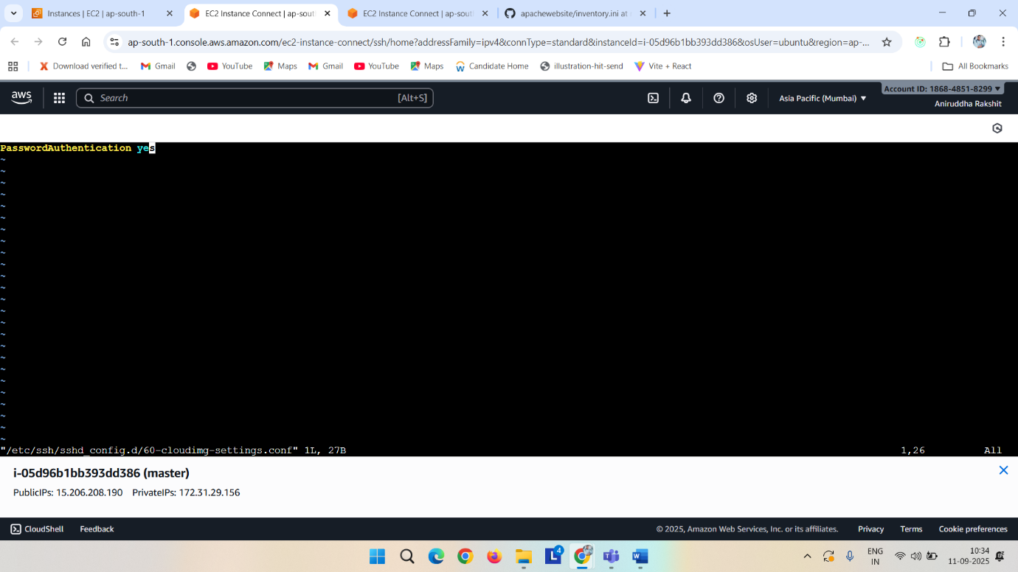

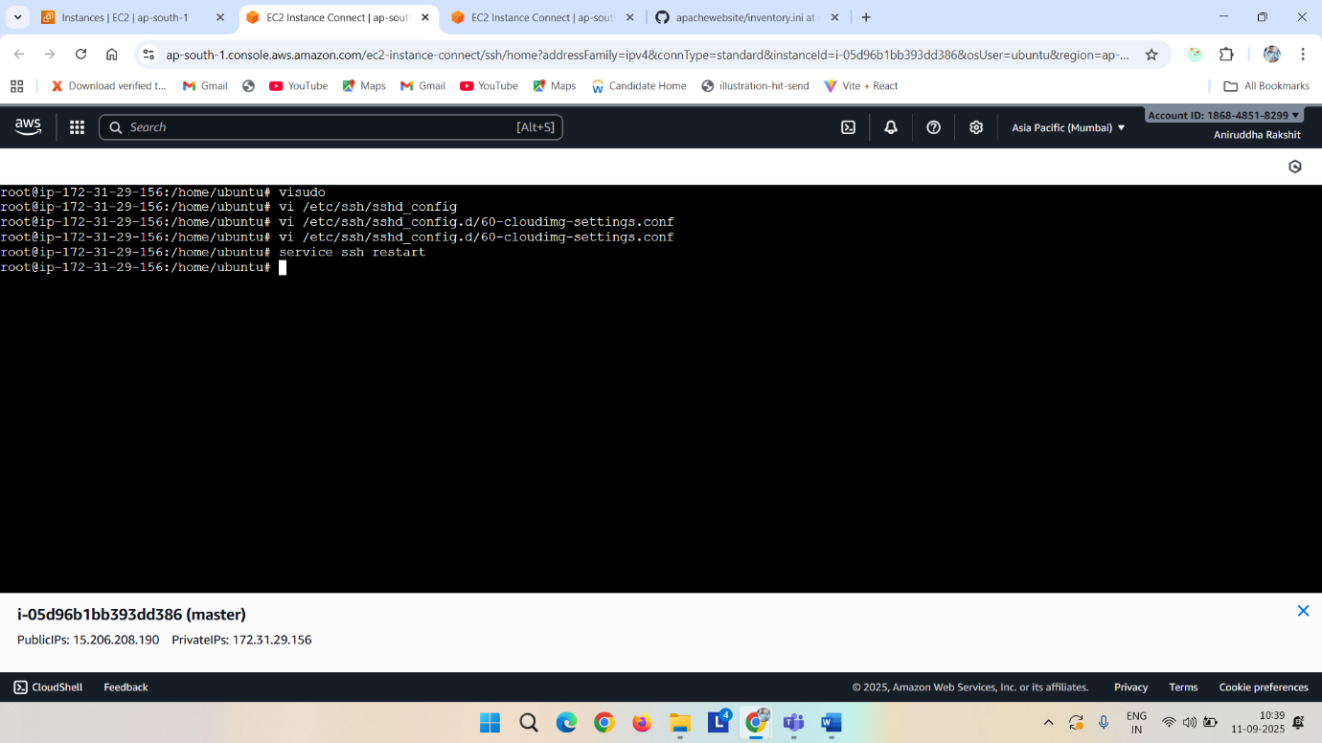

Adduser devops

Su – devops

Ssh -keygen

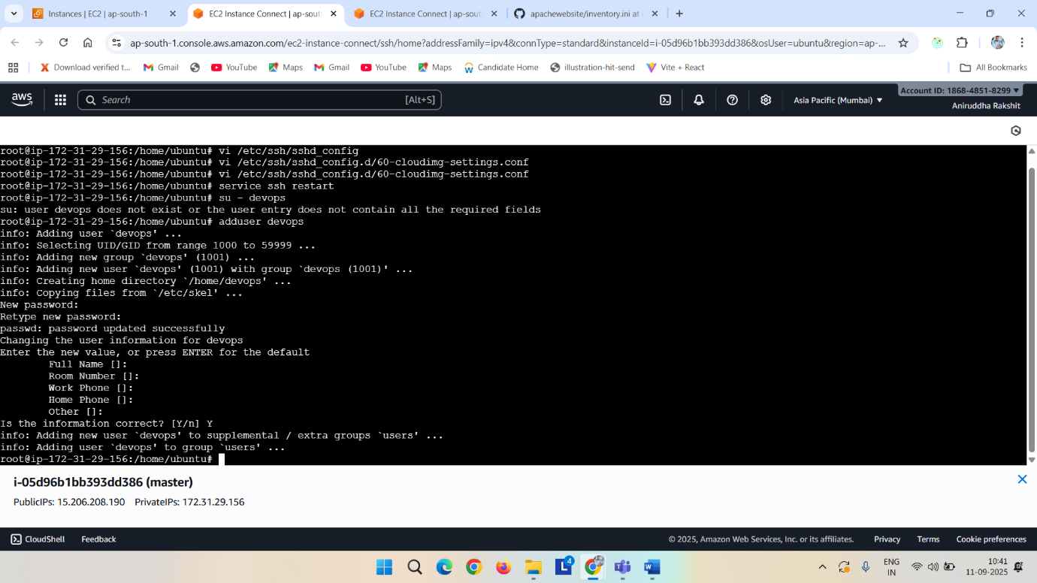

Ls -a

Cd .ssh

Ssh-copy-id devops@<private_ip_of_node2>

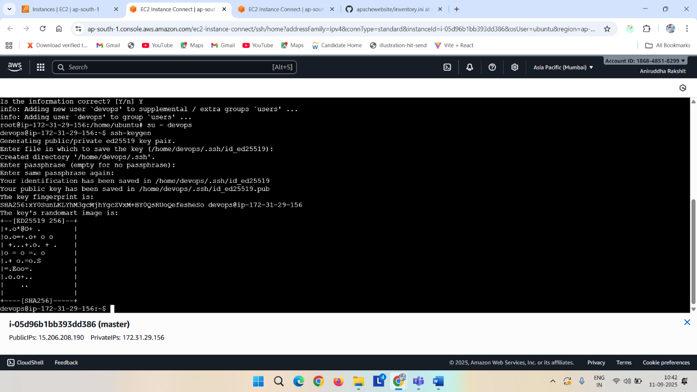

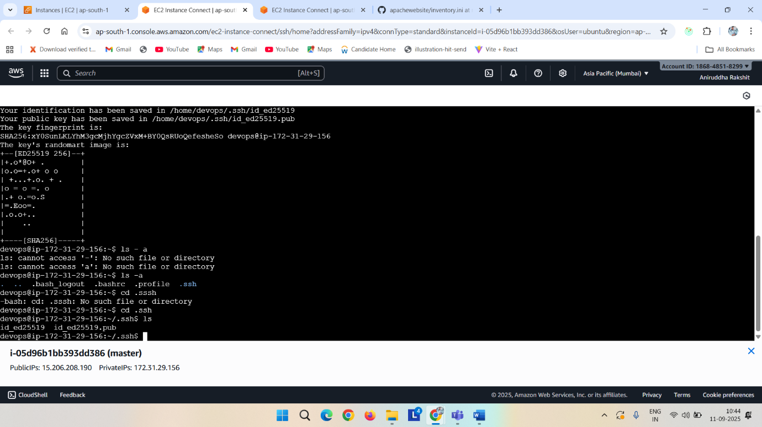

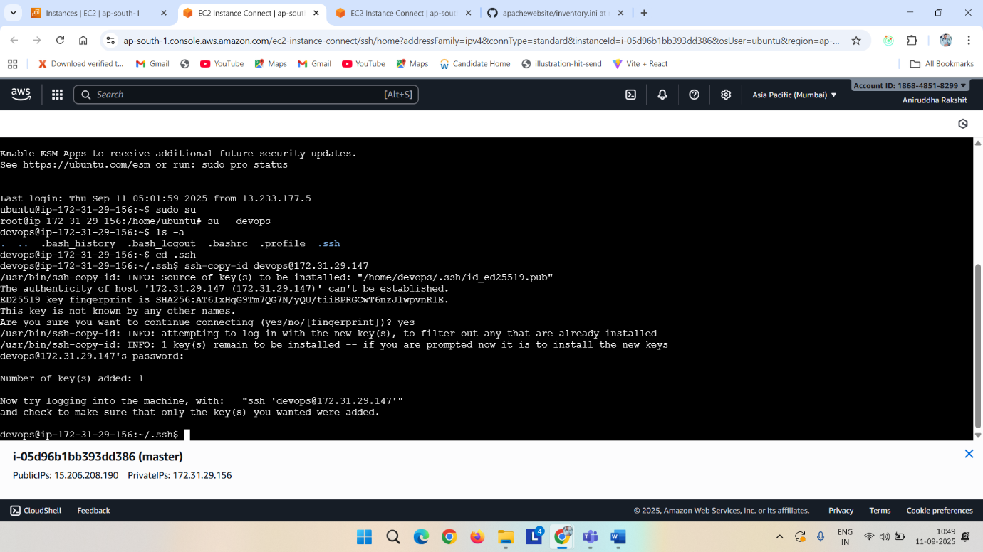

Install plugin

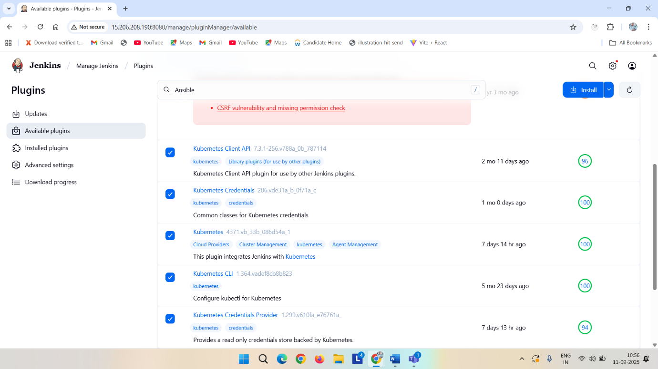

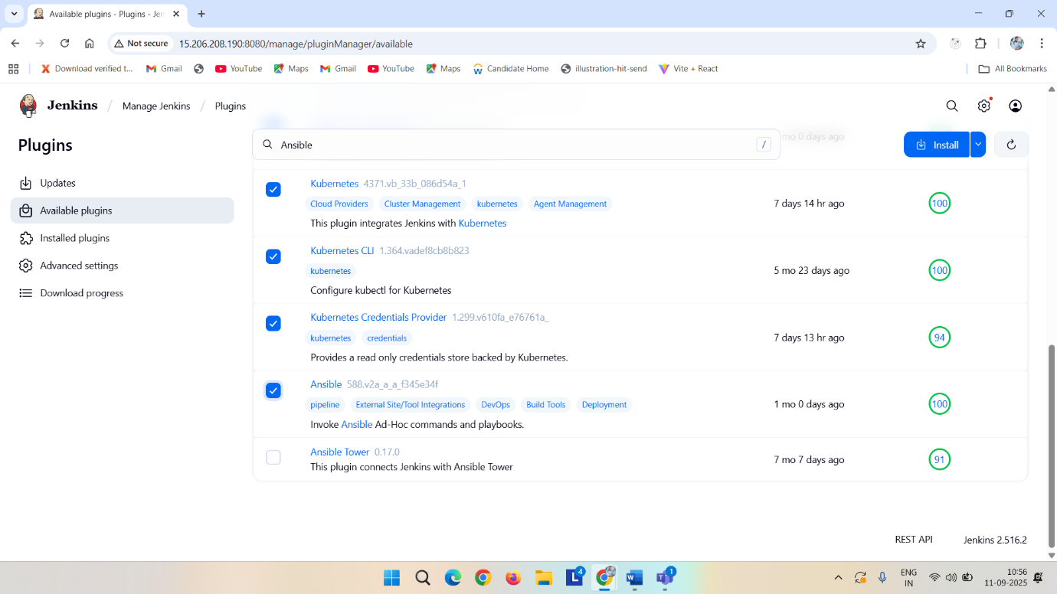

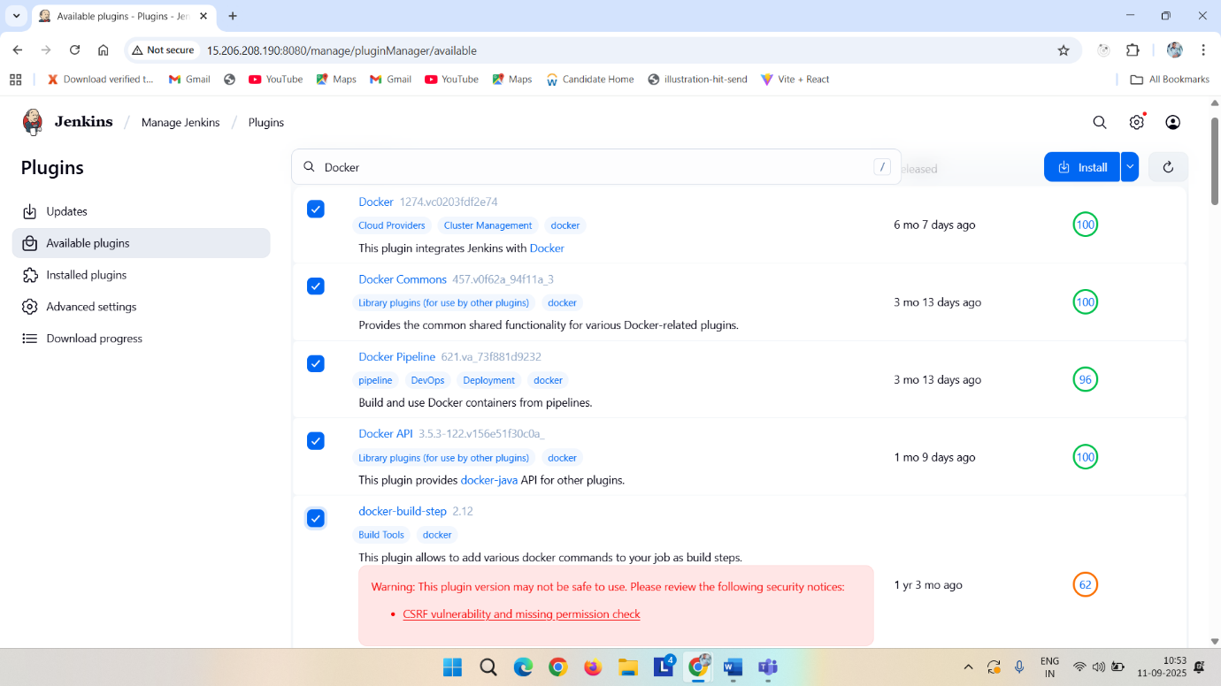

After install restart Jenkins

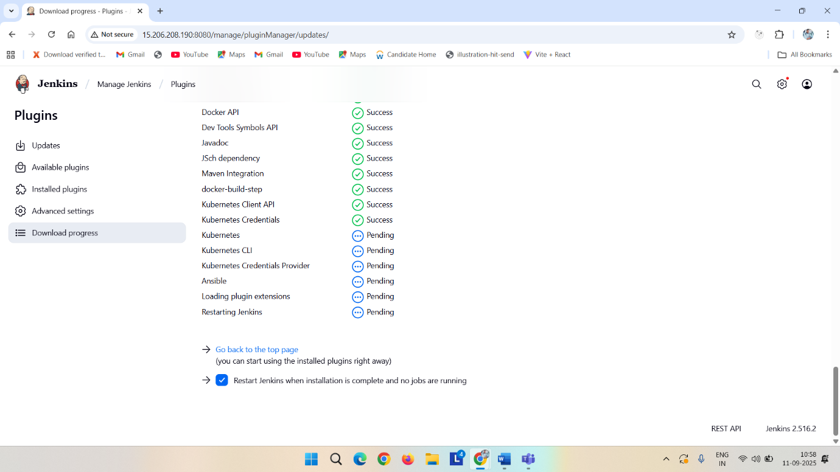

In your terminal write

docker login -u <your_dockerhub_username>

sudo usermod -aG docker Jenkins

sudo systemctl restart Jenkins

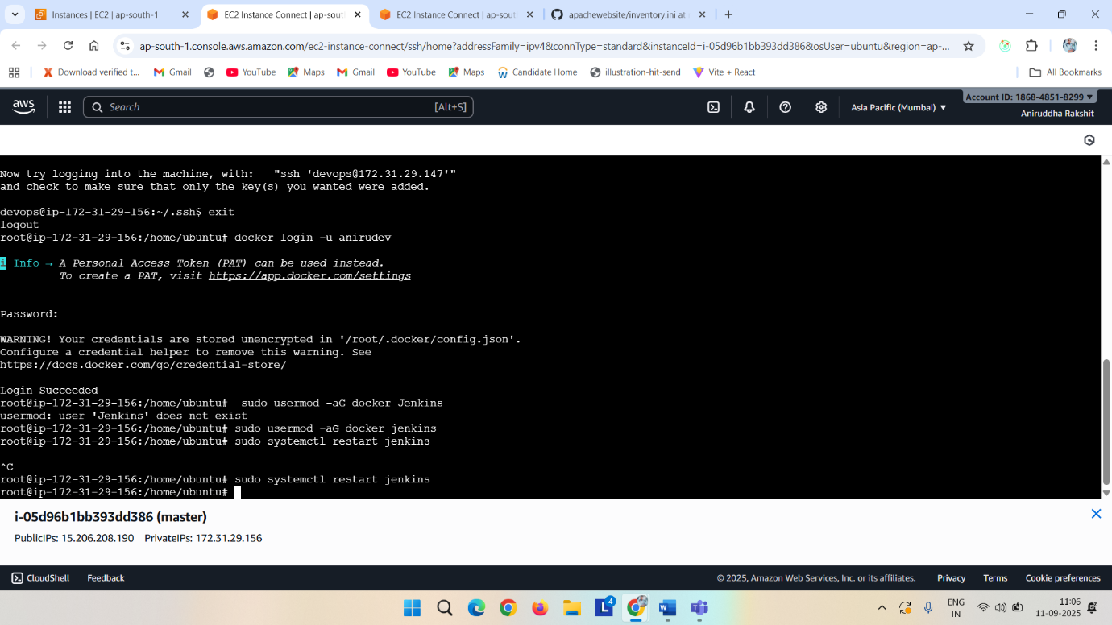

Then login into Jenkins-> go to credentials -> click on global-> add creadentials->username with password (username your dockerhub user name) your docker hub password id : docker-> create

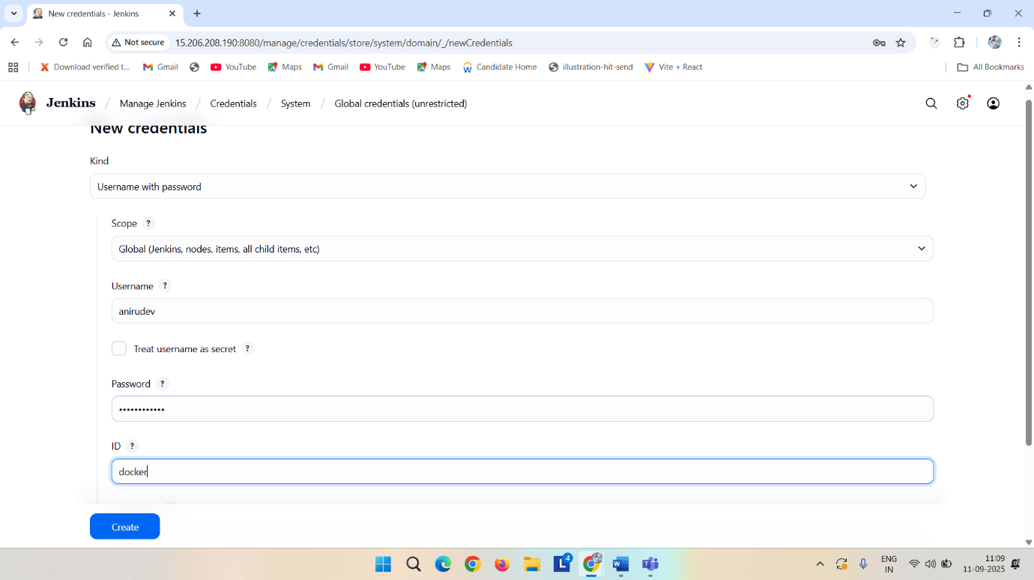

Then again click on add creadential-> kind: ssh username with private key->

For secret text go to your master machine su – devops

Cd .ssh

Cat id_ed25519

Copy it and paste it on secret at Jenkins-> id: ansible-ssh -> create

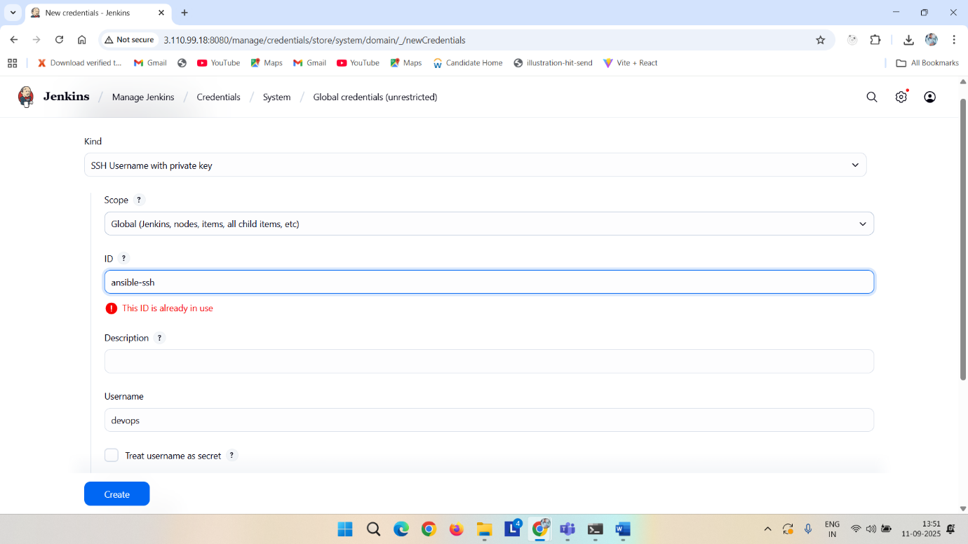

s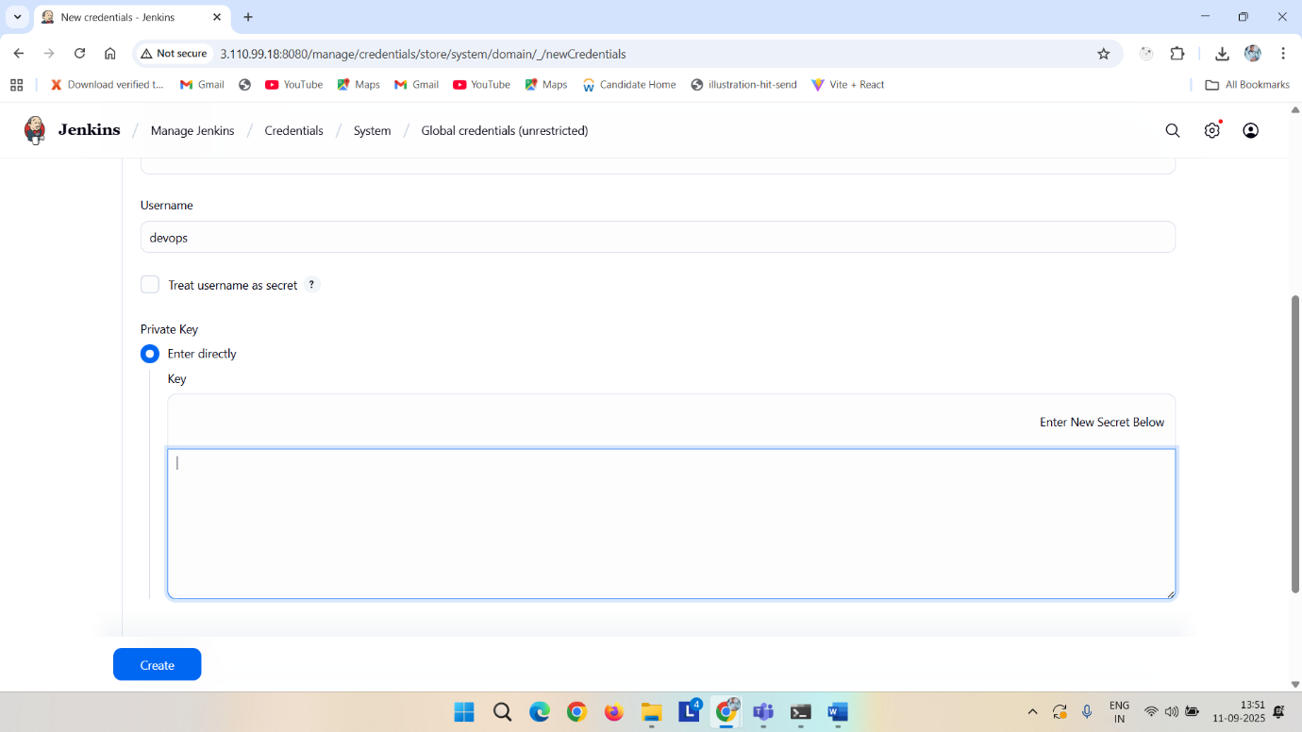

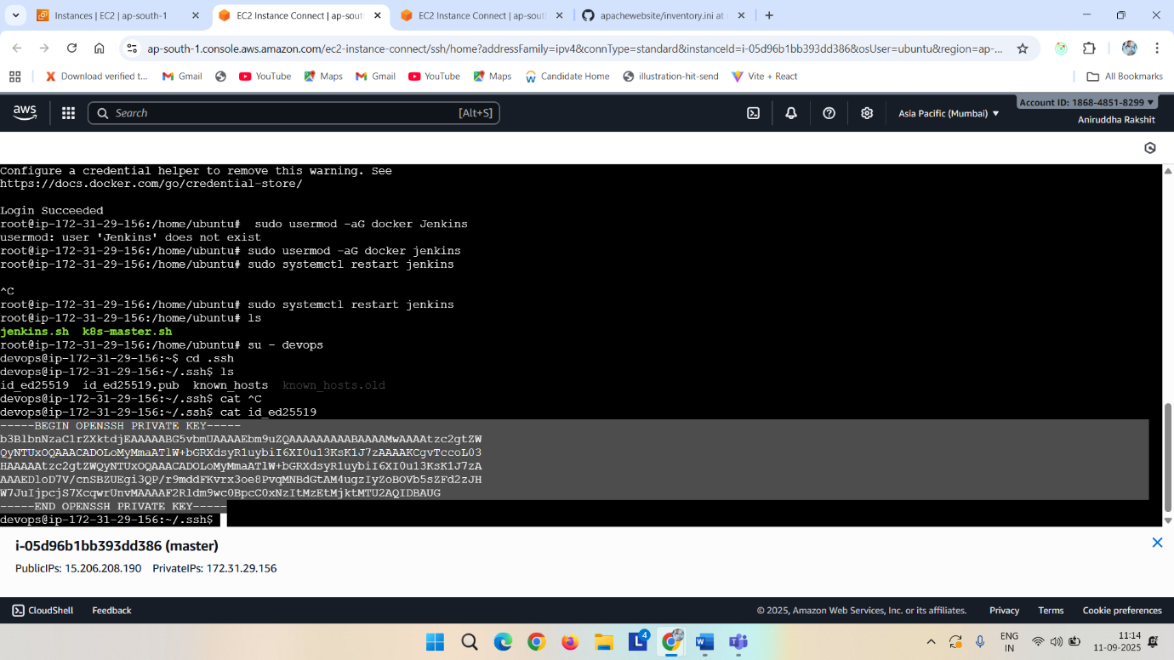

Then again click on add credentials-> kind: secret-file->

On master

cat ~/.kube/config

copy the whole thing end to end and create a file with name kubeconfig with no exrention->

upload the file and id: kubeconfig

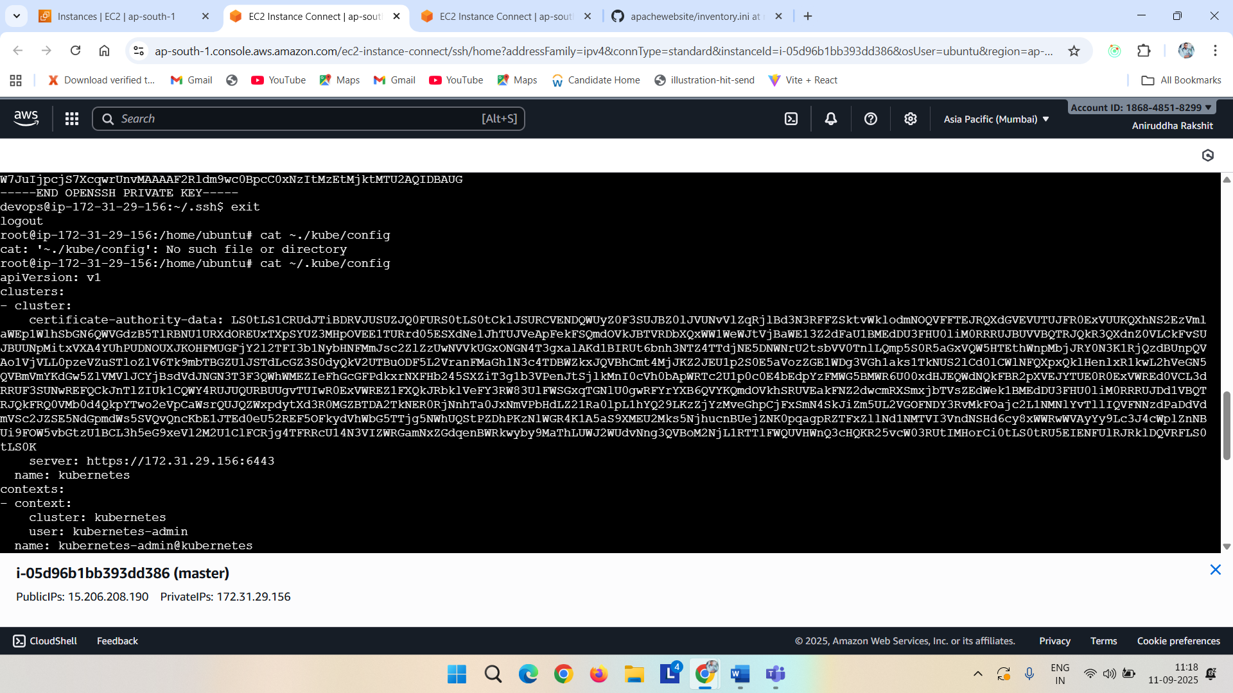

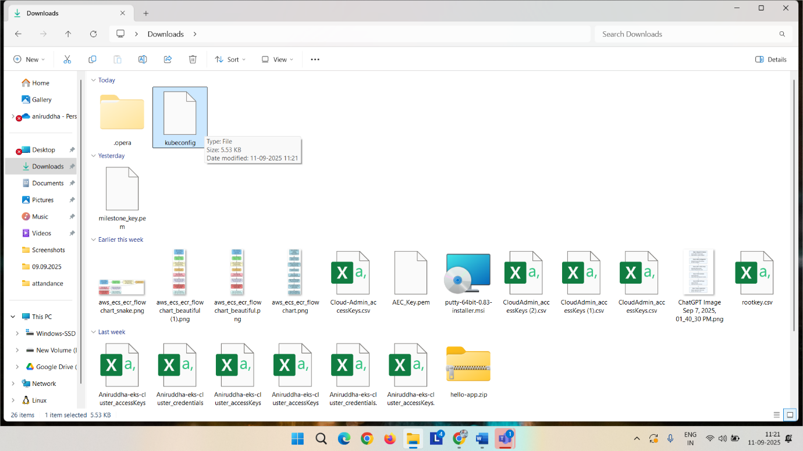

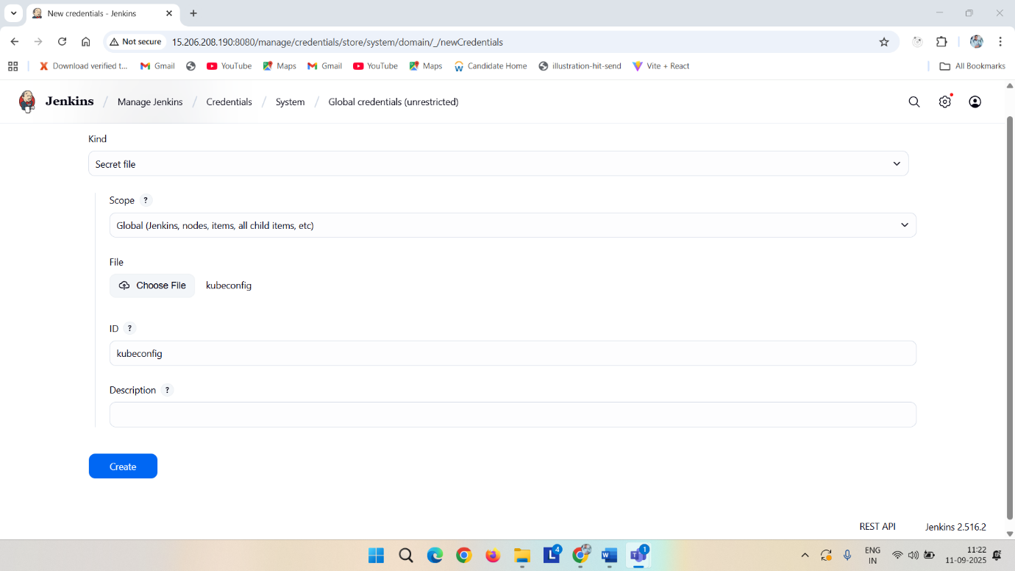

Now write down the deployment script and service script and upload it on git hub foked repo

apiVersion: apps/v1

kind: Deployment

metadata:

name: apachewebsite-deployment

labels:

app: apachewebsite

spec:

replicas: 2 # number of pods

selector:

matchLabels:

app: apachewebsite

template:

metadata:

labels:

app: apachewebsite

spec:

containers:

- name: apachewebsite

image: anirudev/apachewebsite:latest

ports:

- containerPort: 80

Service file

apiVersion: v1

kind: Service

metadata:

name: apachewebsite-service

spec:

selector:

app: apachewebsite

ports:

- protocol: TCP

port: 80 # Service port

targetPort: 80 # Container port

nodePort: 30080 # Optional: fixed NodePort

type: NodePort # Change to LoadBalancer if using cloud provider

and then copy this pipeline code -> at forked repo add a Jenkins file and paste it and change

pipeline {

agent any

environment {

DOCKER_IMAGE = 'anirudev/apachewebsite:latest'

KUBECONFIG = credentials('kubeconfig')

}

stages {

stage('Clone Git repository') {

steps {

git 'https://github.com/RaksAniruddha/apachewebsite.git'

}

}

stage('run ansibleplaybook'){

steps{

ansiblePlaybook credentialsId: 'ansible-ssh', installation: 'ansible2', inventory: 'inventory.ini', playbook: 'installapche.yml', vaultTmpPath: ''

}

}

stage('Docker Build & Push') {

steps {

script {

withDockerRegistry([credentialsId: 'docker', url: 'https://index.docker.io/v1/']) {

sh '''

echo "Building Docker image..."

docker build --no-cache -t $DOCKER_IMAGE -f Dockerfile .

echo "Pushing Docker image to Docker Hub..."

docker push $DOCKER_IMAGE

'''

}

}

}

}

stage('Deploy to Kubernetes') {

steps {

script {

withCredentials([file(credentialsId: 'kubeconfig', variable: 'KUBECONFIG_FILE')]) {

sh '''

echo "Deploying to Kubernetes..."

export KUBECONFIG=$KUBECONFIG_FILE

kubectl apply -f deployment.yml

kubectl apply -f service.yml

echo "Deployment and Service applied successfully!"

'''

}

}

}

}

}

}

Now copy the playbook code from bellow create a file name installapche.yml and paste it in that   
---

- name: Install and start Apache on Ubuntu

hosts: all

become: yes

tasks:

- name: Update apt package index

apt:

update_cache: yes

- name: Install Apache2

apt:

name: apache2

state: present

- name: Ensure Apache2 is running and enabled

service:

name: apache2

state: started

enabled: yes

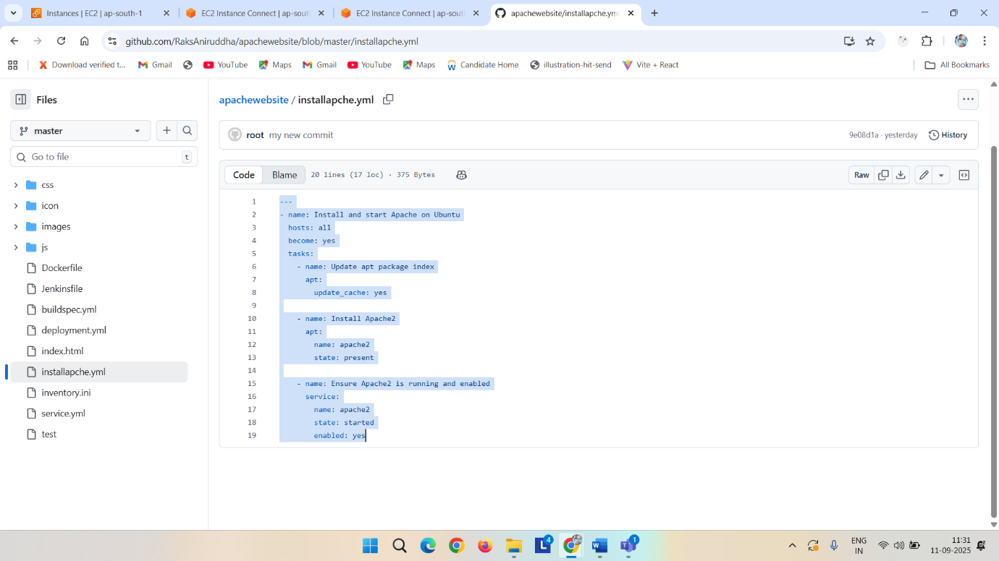

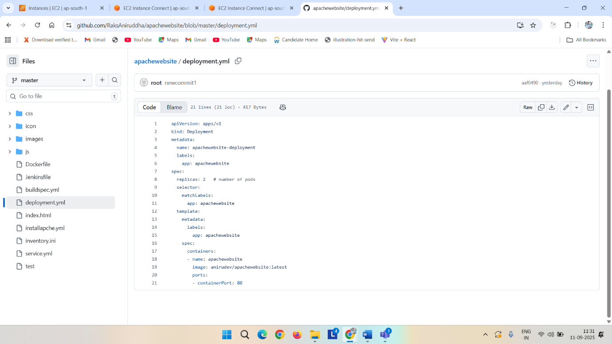

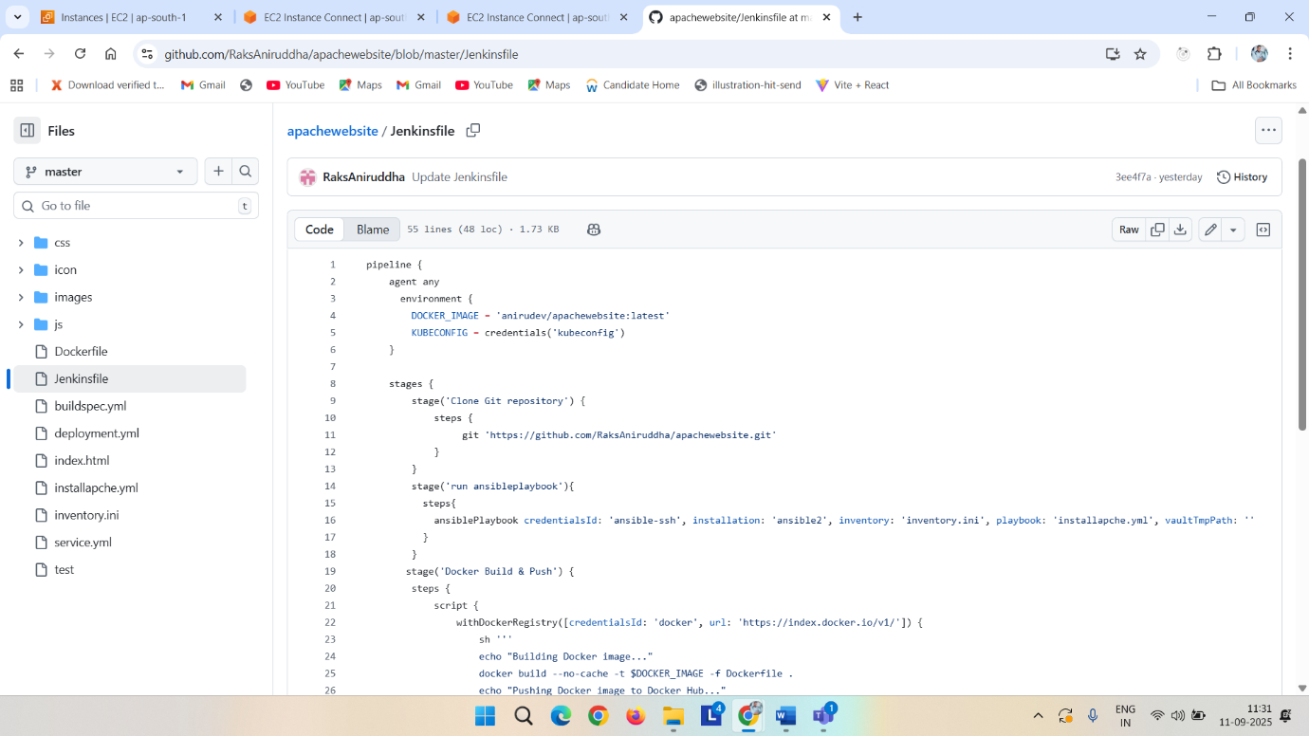

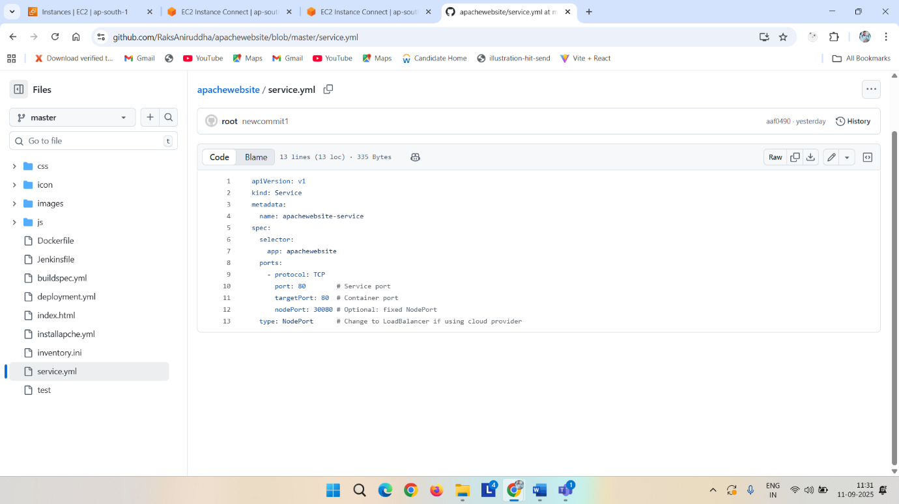

Now go to your jenkins

Clicj on tools -> anisble-> name : ansible-> /usr/bin

Docker-> name : docker-> add installer-> latest->apply save

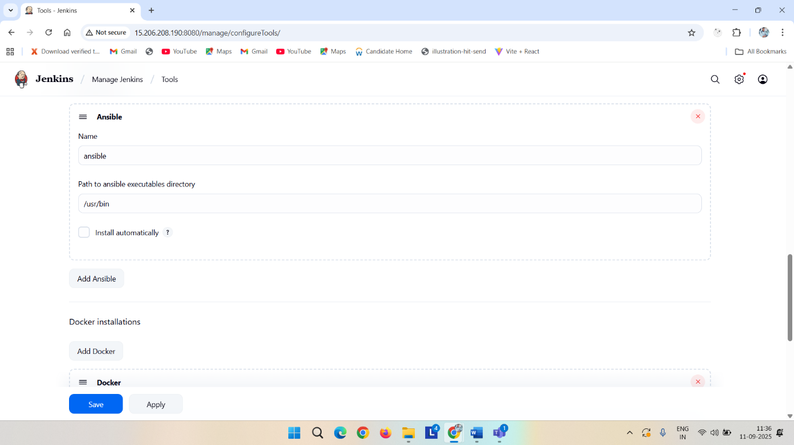

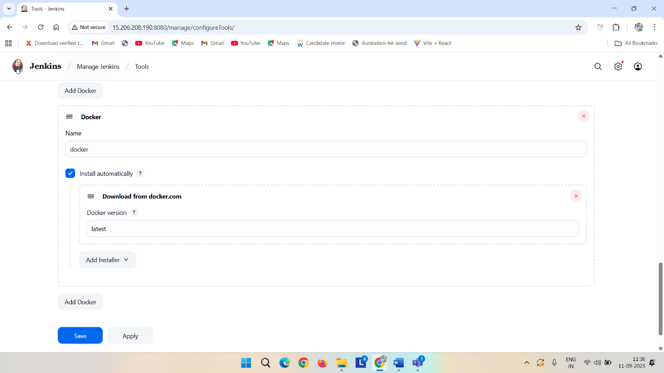

No w go to Jenkins-> go to new item -> pipeline-> ok-> click on pipeline syntax ->click on ansible playbook-> Playbook file path in workspace : give your github playbook filename in my case installpache.yml-> Inventory file path in workspace: inventory.ini (because my github filename is inventory.ini)-> select ssh key-> generate pipeline script-> copy it paste on pipeline{ steps{

ansiblePlaybook credentialsId: 'ansible-ssh', installation: 'ansible2', inventory: 'inventory.ini', playbook: 'installapche.yml', vaultTmpPath: ''

}}

Similary

Again click on pipeline syntax-> select git -> give repo url -> branch (master/main)-> generate pipeline script and paste it at clone stage { stage('Clone Git repository') {

steps {

git 'https://github.com/RaksAniruddha/apachewebsite.git'

}

}

}

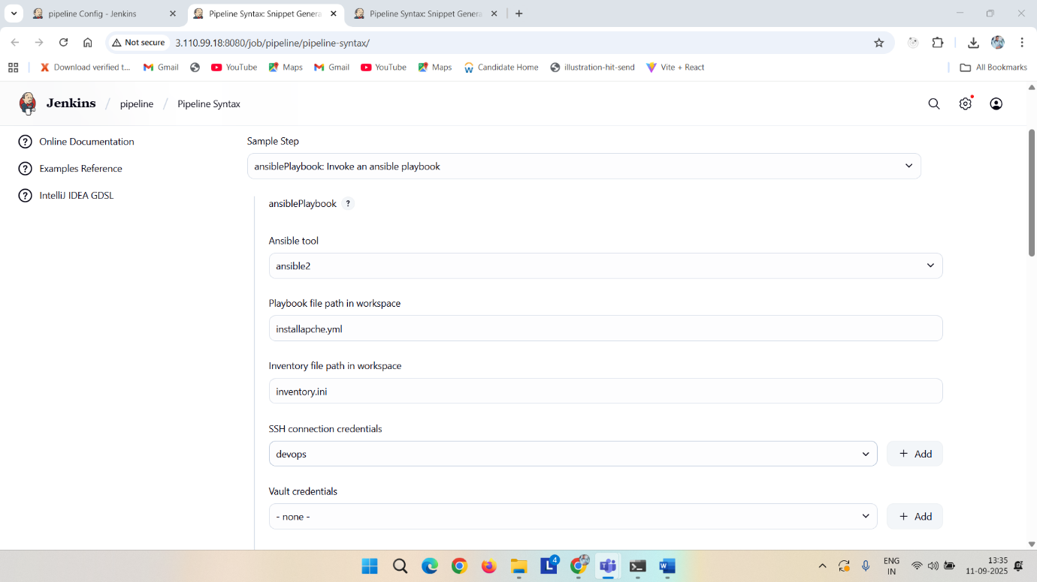

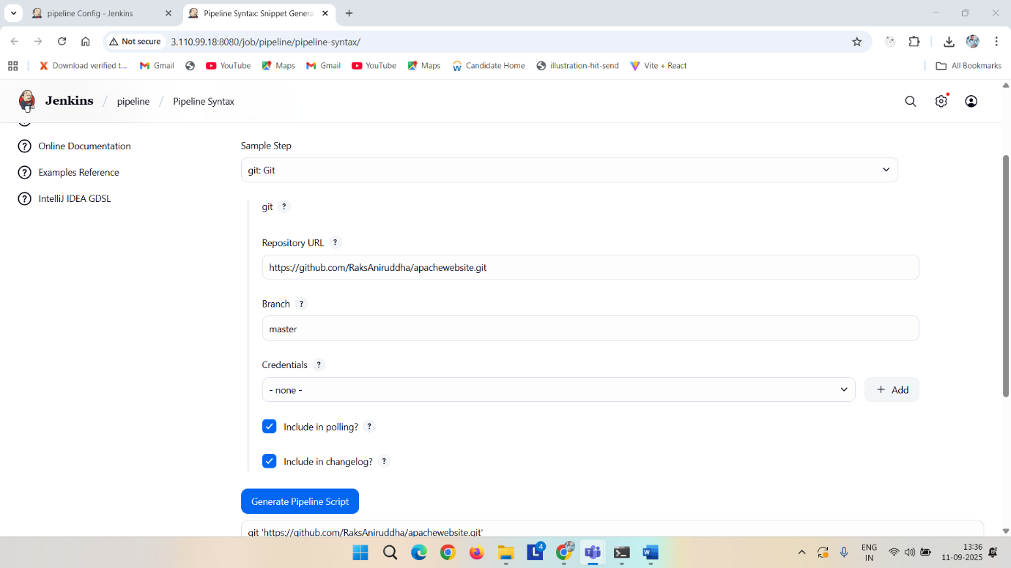

Now in the pipeline slelect checkout from scm -> give repository url-> slect branch master -> apply _> save-> run

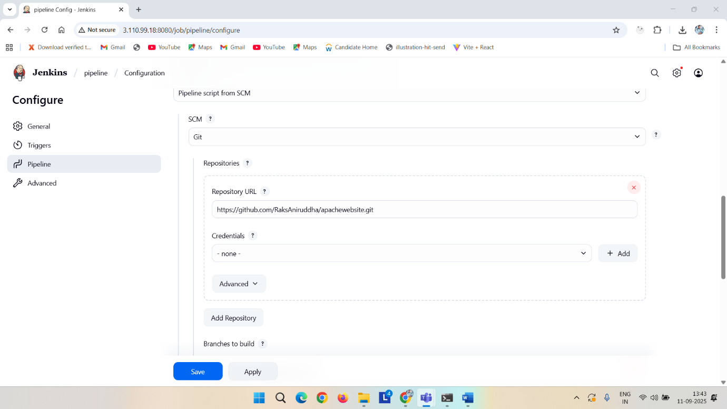

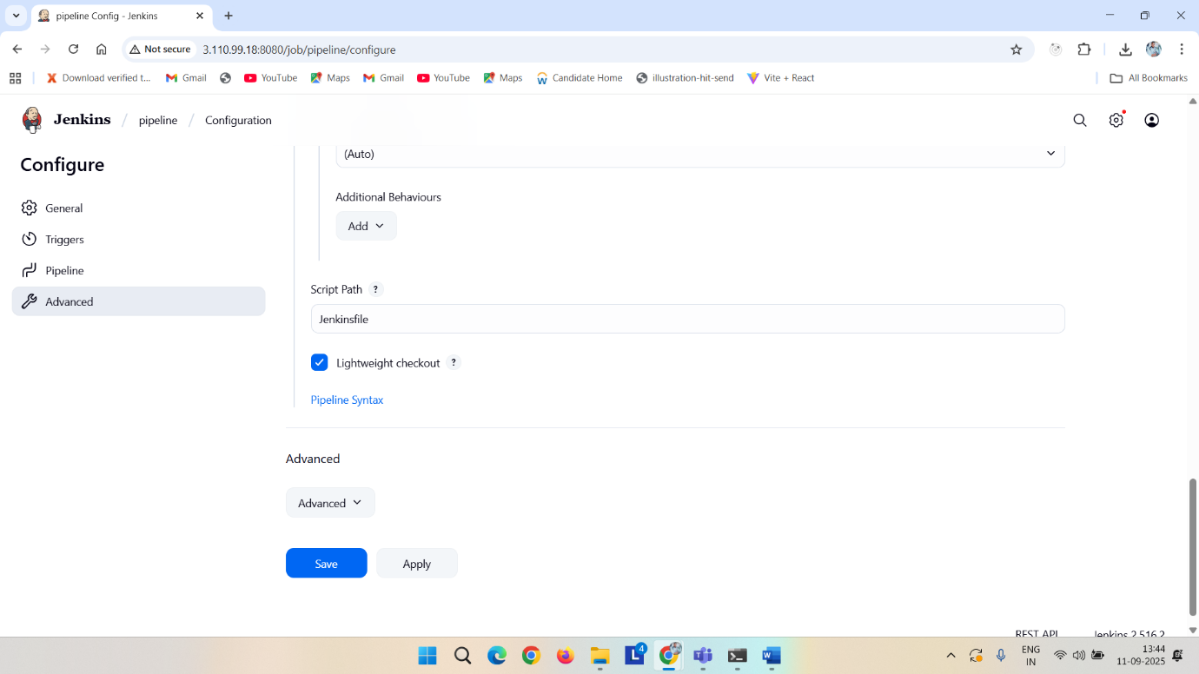

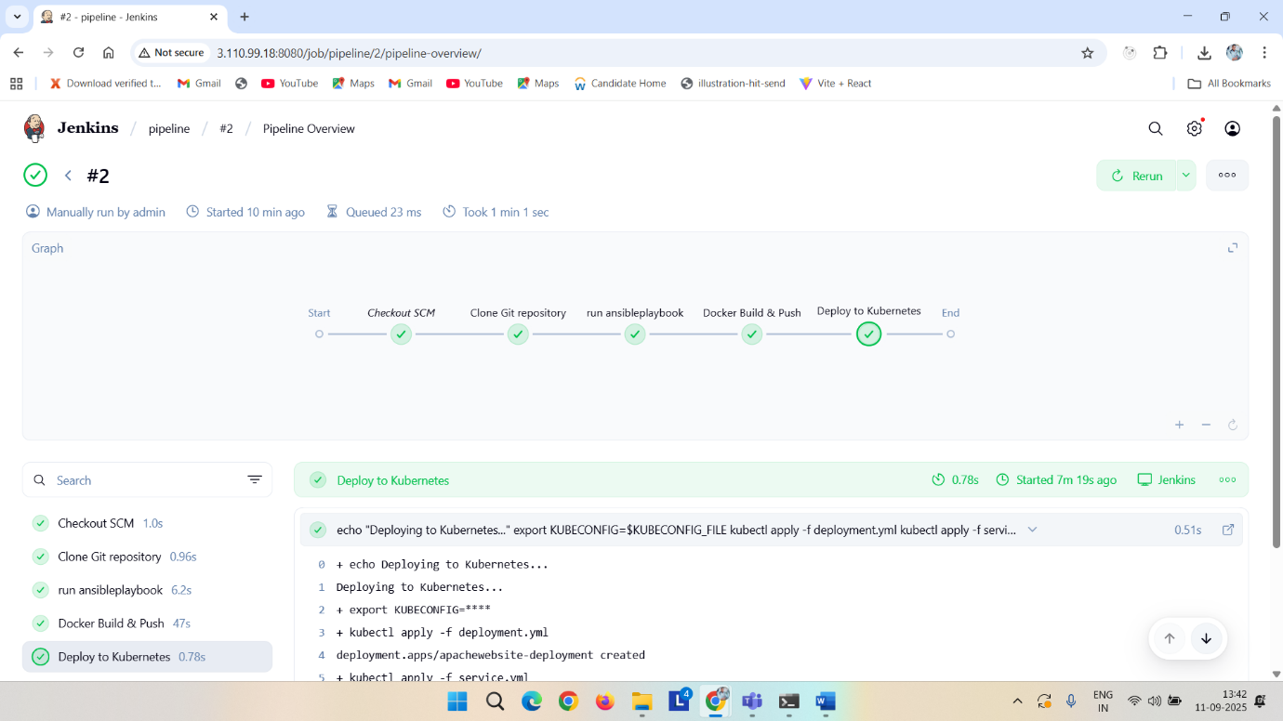

Kubectl get pods -o wide

Kubectl get svc -o wide

You will got at port collum 80:<external_port>

In my case 80:30080 so I copy 30080

Then go to your browser <publicipof node>:30080

